

**ADDIS ABABA INSTITUTE OF TECHNOLOGY**

**CENTER OF INFORMATION TECHNOLOGY AND SCIENTIFIC COMPUTING**

DEPARTMENT OF INFORMATION TECHNOLOGY

Finger Spellings Recognition for Ethiopian Sign Language

Team Members

1. Buruk Sahilu ATR/7166/07
2. Daniel Moges ATR/6585/07
3. Natnael Berhanu ATR/7159/07
4. Yohannes Endale ATR/0842/07

Advisor: Nebiat Fikru

March 2018

**Addis Ababa Institute of Technology**

**Information Technology and Scientific Computing**

Finger Spelling Recognition for Ethiopian Sign Language

This Project documentation submitted in partial fulfillment of the requirements for the Degree of Bachelor of Science in **IT**.

**Project Advised by:**

Advisor Name: Nebiat Fikru

Name and signature of Members of the examining board:

Name Title Signature Date

1. __________________ Advisor _____________ _____________
2. __________________ Chairperson _____________ _____________
3. __________________ Examiner _____________ _____________
4. __________________ Examiner _____________ _____________
5. __________________ Examiner _____________ _____________

March 2018

**Declaration of Originality**

We declare that this project is our original work and has not been presented for a degree in any other university.

Name Signature Date

1. Name of Student 1 Buruk Sahilu_______ March 6, 2018_______
2. Name of Student 2 Daniel Moges ___ March 6, 2018_______
3. Name of Student 3 Natnael Berhanu _ March 6, 2018_______
4. Name of Student 4 Yohannes Endale _ March 6, 2018_______

This project documentation has been submitted for examination with my approval as university advisor:

Advisor Name: Nebiat Fikru

March 2018

**ACKNOWLEDGEMENT**

We the development team, would like to express our very great appreciation to the Center of Information Technology and Scientific Computing(ITSC) for enabling us to undertake the first phase of our final project, which is this documentation.

There are a lot of peoples who have helped us to grow this idea into what it is now. So we would like to thank these peoples for their support. And also like to thank Addis Ababa Institute of Technology department of ITSC staff specifically the committee who are going to see this work and give us their view on the project proposal.

**ABSTRACT**

Humans interact with each other using a natural language channel such as words, writing, or by body language (gesture). As understanding natural language is important, understanding sign language is also very important. The sign language is the basic communication method between people with a hearing disability. People with hearing disability face problems in communicating without a translator. For this reason, the introduction of a system that recognizes sign language would have a significant benefit impact on deaf people’s social life. In this paper we have proposed visual Ethiopian sign language recognition system using image processing, computer vision and neural network methodologies, to identify the characteristics of the hand in image taken through web camera. This approach will convert video of daily frequently used full sentence gestures into text.

**Table of Contents**

**List of Figures** ix

**List of Tables** x

**ACRONYMS** xii

**Chapter 1: INTRODUCTION** 1

**1.1 Background** 1

**1.2 The Existing System** 3

**1.4 Objective of the Project** 5

**1.4.1** **General Objective** 5

**1.4.2** **Specific Objective** 5

**1.5 Proposed System** 5

**1.6 Feasibility Study** 6

**1.6.1 Economic Feasibility** 6

**1.6.2 Technical Feasibility** 7

**1.6.3 Schedule Feasibility** 7

**1.7 Scope** 7

**Limitation** 8

**1.8** **Methodology** 8

**1.8.1** **Data Collection** 8

**Software Developing Methodology** 9

**1.9 Project Management plan** 10

**1.9.1. Time Management plan** 10

**1.9** **.2 Quality Management Plan** 12

**1.9 .3 Communication Management Plan** 12

**Chapter 2: Requirement Analysis** 14

**2.1 Introduction** 14

**2.2 General Description** 14

**2.3 Product Perspective** 14

**2.4 Product Functions** 15

**2.5 User Characteristics** 17

**2.6 General Constraints** 17

**2.7 Assumptions and Dependencies** 17

**2.8 External Interface Requirements** 17

**2.8.1 User Interfaces** 17

**2.8.2 Hardware Interfaces** 18

**2.8.3 Software Interfaces** 18

**2.8.4 Communications Interfaces** 18

**2.9 Functional Requirements** 19

**2.10 Use Cases** 22

**2.10.1 Use Case #1 Input Video** 23

**2.10.2 Use Case #2 Segment Hand** 24

**Name:** Segment Hand 24

**2.10.3 Use Case #3 Extract Feature** 25

**2.10.4 Use Case #4 Classification** 26

**2.10.5 Use Case #5 Translate sign to text** 27

**2.11 Non-Functional Requirements** 28

**2.11.1 Performance** 28

**2.11.2 Maintainability** 28

**2.12 Inverse Requirements** 28

**2.13 Design Constraints** 29

**2.14 Logical Database Requirements** 29

**2.15 Other Requirements** 29

**2.16 Change Management Process** 30

**Chapter 3: SYSTEM DESIGN** 31

**3.1 General Overview** 31

**3.2 Development Methods & Contingencies** 33

**3.3 System Architecture** 34

**3.3.1 Subsystem decomposition** 34

**3.3.2 Hardware/software mapping** 35

**3.4 Object Model** 36

**3.4.1 Class Diagram** 36

**3.4.2 Sequence Diagram** 40

41

**3.5 Detailed Design** 43

**Chapter 5: Testing** 57

5.1 Introduction 57

5.2 Features to be tested/not to be tested 57

5.2.1 Features to be tested 57

5.2.2 Features not to be tested 57

5.3. Pass/Fail criteria 57

5.4. Approach/Strategy 57

**Chapter 6: User Manual** 59

6.1 scope 59

6.2 Installation and configuration 59

6.3 How to operate the system 63

**Chapter 7: CONCLUSION AND RECOMMENDATION** 67

**7.1 Conclusion** 67

**7.2 Recommendation** 67

**BIBLIOGRAPHY** 68

**APPENDIX** 69

A.1 Appendix 1 69

A.2 Appendix 2 69

# **List of Figures**

Figure 1 Ethiopian Finger Spelling 2

Figure 2 System Architecture 6

Figure 3 Gantt chart 10

Figure 4 System Architecture 15

Figure 5 User Interface 18

Figure 6 Use Case Diagram 22

Figure 7 system architecture for FSRFEthSL 31

Figure 8 high-level context diagram for FSRFEthSL 32

Figure 9 data flow diagram for FSRFEthSL 32

Figure 10 level 2 data flow diagram for FSRFEthSL 33

Figure 11 Component diagram for FSRFEthSL 34

Figure 12 Deployment Diagram for FSRFEthSL 35

Figure 13 Translation Engine Module class Diagram for FSRFEthSL 36

Figure 14 Hand Segmentation class Diagram for FSRFEthSL 37

Figure 15 feature extraction class diagram for FSRFEthSL 38

Figure 16 Classification class diagram for FSRFEthSL 39

Figure 17 hand segmentation sequence diagram for FSRFEthSL 40

Figure 18 Feature extraction sequence diagram for FSRFEthSL 41

Figure 19 Classification sequence diagram for FSRFEthSL 42

# **List of Tables**

Table 1 Time management Plan 11

Table 2 Communication Management Plan 13

Table 3 Functional Requirement 01 19

Table 4 Functional Requirement 02 19

Table 5 Functional Requirement 03 20

Table 6 Functional Requirement 04 20

Table 7 Functional Requirement 05 21

Table 8 Functional Requirement 06 21

Table 9 UI class 43

Table 10 Attributes description for UI class 43

Table 11 Operation description for UI class 43

Table 12 Video class 44

Table 13 Attributes description for Video class 44

Table 14 Operation description for Video class 44

Table 15 Engine class 45

Table 16 Attributes description for Engine class 45

Table 17 Operation description for Engine class 45

Table 18 Request class 46

Table 19 Attributes description for Request class 46

Table 20 BackgroundRemoval class 46

Table 21 Attributes description for BackgroundRemoval class 46

Table 22 Operation description for BackgroundRemoval class 47

Table 23 Threshold class 48

Table 24 Attributes description for Threshold class 48

Table 25 Operation description for Threshold class 48

Table 26 CounterExtraction class 49

Table 27 Attributes description for CounterExtraction class 49

Table 28 Operation description for CounterExtraction class 49

Table 29 FeatureExtractionMain class 50

Table 30 Attributes description for FeatureExtractionMain class 50

Table 31 Operation description for Mobile Client class 50

Table 32 Feature class 51

Table 33 Attributes description for Feature class 51

Table 34 AbstractProcess 51

Table 35 Attributes description for Mobile Client class 51

Table 36 Operation description for Mobile Client class 52

Table 37 RowPixelGenerator 52

Table 38 Attributes description for RowPixelGenerator class 52

Table 39 Operation description for RowPixelGenerator class 52

Table 40 CenterOfMass 53

Table 41 Operation description for CenterOfMass class 53

Table 42 LastFirstFrame class 53

Table 43 Operation description for LastFirstFrame class 54

Table 44 SupervisedLearner class 54

Table 45 Operation description for SupervisedLearner class 55

Table 46 Dataset class 55

Table 47 Operation description for Dataset class 56

Table 48 Model class 56

Table 49 Operation description for SupervisedLearner class 56

# **ACRONYMS**

|  |  |
| --- | --- |
| WHO | World Health Organization |
| E.C | Ethiopian Calendar |
| CNN | Convolutional Neural Network |
| HMM | Hidden Markov Model |
| SRS | Software Requirement Specification |
| EthSL | Ethiopian Sign Language |
| SVM | Supervised Machine Learning |
| GUI | Graphical User Interface |
| CNN | Convolutional Neural Network |
| API | Application Programming Interface |
| GPL | General Public License |
| FSRFEthSL | Finger Spelling Recognition for  Ethiopian Sign Language |

# **Chapter 1: INTRODUCTION**

## **1.1** **Background**

One of the many physical disabilities people face is being hearing-impaired. According to WHO [1], over 5% of the world’s population (360 million people) has a disabling hearing loss. A person is said to have a disabling hearing loss if s/he has a hearing loss that is greater than 40dB. Hearing loss can result from many causes, some of which are genetic, complications at birth, certain infectious diseases, chronic ear infections, the use of particular drugs, exposure to excessive noise and aging.

In Ethiopia,according to 2007 E.C census, 1.1% of the population (805,492) [2] have disabilities. Among this population, 18.2% (146,913) have hearing disability. From children born with disability, only 2% have access to proper school education [3].

**Sign Language**

Deaf people use sign language [4] to communicate with others. Sign language is defined as a language which uses manual communication such as hand gestures, facial expressions and movements of arms or body to convey meaning as opposed to acoustically conveyed sound patterns. Wherever deaf people exist, sign languages have developed as a means of communication.

According to Ethnologue [5], there are about 138 sign languages in the world. Each sign language is named after the geographical location it is widely used in. For example, we say American Sign Language to refer to the sign language used in America. A common misconception among people who are new to sign language is to assume that sign languages are named after spoken languages. For instance, there is no Amharic sign language, or Oromiffa Sign language; there is only Ethiopian Sign Language.

Sign language has its own rules, structure and grammar. The following are the basic components of sign language [7].

* Hand shape
* Hand movement
* Orientation
* Location
* Non manual features like facial gestures.

Ethiopian Sign language is originated from American Sign Language with some influence from the Nordic Countries [7, 8]. The language also includes local signs which originated from local deaf schools. The language didn’t get the chance to be developed and standardize like spoken languages [9]. Ethiopian finger spelling is developed by ENAD in 1971. ENAD also developed Ethiopian Sign

Language dictionary in 2008. In Ethiopian sign language there are distinct finger spelling signs for the 33 ‘Geez Fidel’ and their corresponding letters with vowels.

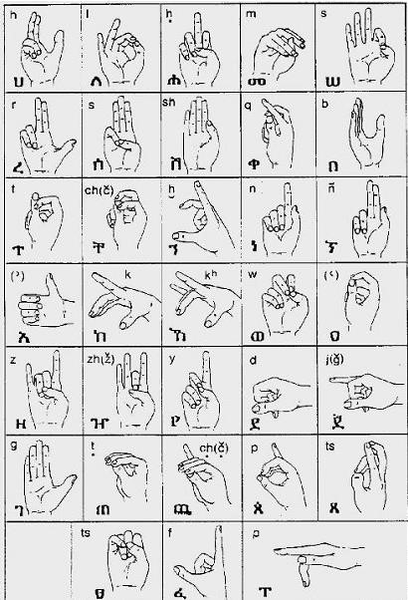

Figure 1 Ethiopian Finger Spelling

Deaf education in Ethiopia began in the 1950s, which was given by foreigners teaching in missionary schools. The Ethiopian sign language has been used at primary school level since 1956 [6] and at higher school levels since 1971. However, its use is limited to small portion of the deaf community.

This is due to the small number of deaf people getting proper school education.

## **1.2 The Existing System**

The work in [11] discusses vision based finger spelling recognition for Ethiopian Sign Language. This work is a continuation of a previous research work [12] which was able to recognize finger spelling for Ethiopian sign language without considering vowels. The work in [11] extends the study for the recognition of Ethiopian finger spelling with their corresponding vowels. The additions of vowels in the finger spelling will add movements to the basic finger shapes of the consonants.

The work used distance based selection technique to select frames from the input videos. After selecting the frames, the next step was preprocessing the selected frames to detect the hand from the other parts of the body. In this process image processing techniques such as converting RGB to Gray scale, adjusting brightness and removing noise with the help of median filter were conducted. Global thresholding was also applied to segment components. Grouping neighborhood was the other technique to select the largest component which was considered as a signed hand. By calculating the distance between the centers of masses of the detected signs in two consecutive frames, it was possible to identify the motion of the hand which was very useful in determining the corresponding vowel of the finger spelling. Finite state automata were the preferred technique for the process of recognition of the finger spelling.

The signers wore white gloves with long sleeved black shirts to segment hands from other parts of the body parts using image processing algorithms. The videos were captured in a constant background. Four signers participated in performing 238 Ethiopian finger spellings. The overall performance of the work was 90.76%.

The system in [14] accepts a video of isolated sign of Ethiopian sign language and generates equivalent text as an output. This system has five main components Skin color detection, Hands and Head segmentation, extracting features from the segmented body parts, Training HMM model using the extracted features and Recognition.

The process of skin detection applied an algorithm from Mahidra [13] and to get more precise segmentation of the hands and the head we used various filtering algorithms and the 8- connected method. Baum Welch algorithm is used for training our HMM model. They trained a separate model for each sign and Viterbi decoding applied in the recognition process. In this research 3 signers participated and each signer performed a sign 20 times. Out of these 20 videos they used 15 for training and the rest 5 video for testing purpose. The system has been tested using the videos which were captured for training purpose. They found overall recognition of 86.9% using the HMMs trained by 8 features whereas we found the overall recognition of 83.5% using the HMMs trained by only 3 features.

**1.3. Statement of the Problem**

Sign language is a primary tool for the deaf people to communicate with the community around them. But most hearing people do not have the knowledge of sign language. This situation leads to creation of a huge communication gap between the deaf and hearing people. The problems are expressed as follows:

* A communication gap to interact with the hearing people to accomplish their daily tasks. Most of the deaf people have the problem of writing and speaking. This problem is more visible on those deaf people who lost their hearing ability since birth. The inability of writing and speaking widens the communication gap with the hearing people [9].
* Problems that are encountered in the formal education process that includes o Lack of sufficient interpreters for each school in which deaf students are enrolled [9, 10].

o The knowledge of the interpreter is limited to translate the subject matter [10].

* The number of schools that provide sign language translation service are very limited [9,10]. • The problems are also visible in health institutions. Since health professionals need accurate input from the patient to conduct examination, there should be some way to mediate the deaf patients and the health professional [10].

These communication gaps can be narrowed by the help of interpreters. But this solution is not applicable in all situations because

* + There are very limited interpreters [1, 2].
  + There are some issues such as court cases that must be kept secret from the interpreters [2].

Therefore, some technological solutions should be prepared to solve the communication gap between the hearing and deaf people.

## **1.4 Objective of the Project**

### **General Objective**

The general objective of this study is to design a model which can interpret isolated (fingerspelling) signs in Ethiopian Sign Language and give equivalent text to a given sign.

### **Specific Objective**

The specific objectives of the study are

* Study the structure of Ethiopian Sign Language.
* Find suitable existing model to extract a sign from a given video.
* Develop a method to convert the extracted sign to equivalent voice.
* Develop a prototype which demonstrates the translation of the given sign to equivalent text.
* Test the model.

## **1.5 Proposed System**

The proposed System consists of three tasks to be done in real time:

1. Obtaining video of the user signing (input)
2. Classifying each frame in the video to a letter
3. Reconstructing and displaying the most likely word from classification scores (output)

Our system features a pipeline that takes video of a user signing a word as input. We then extract individual frames of the video and generate letter probabilities for each using a CNN with the use of a variety of heuristics, we group the frames based on the character index that each frame is suspected to correspond to. Finally, we use a language model in order to output a likely word to the user.

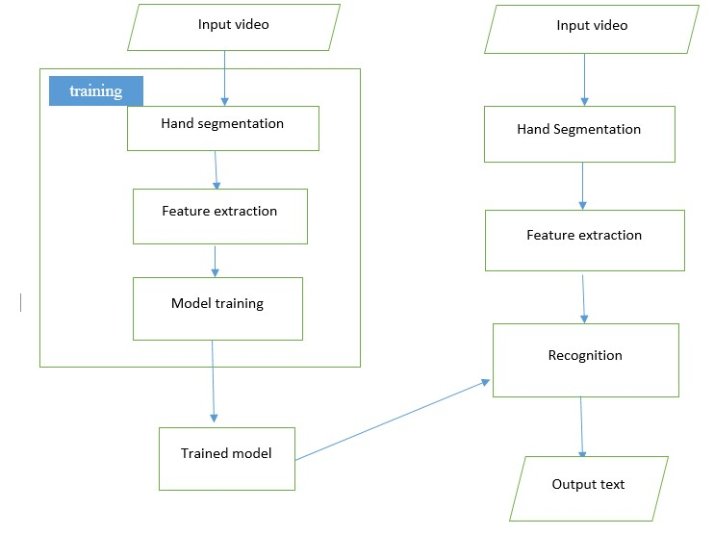

Figure 2 System Architecture

## **1.6 Feasibility Study**

In this section we will try to analyses project's viability and its degree of being easily or conveniently done. There are many challenges on this project and we will try to be prepared for them as much as possible. That way we will not have problem after the project start.

### **1.6.1 Economic Feasibility**

#### **1.6.1.1 Developmental cost**

The technical resources used in this process are mostly found freely. For example OpenCV (Open Source Computer Vision Library) is released under a BSD license and hence it's free for both academic and commercial use, TensorFlow is an open-source software library for dataflow programming across a range of tasks. It is a symbolic math library, and also used for machine learning.

#### **1.6.1.2 Operational Cost**

#### There will be additional costs like copying printing and material fulfilment.

### **1.6.2 Technical Feasibility**

We believe that the system will be feasible because of the number of resources available online for this project. There are two difficulties we will be facing on this project. The first one is obtaining datasets, the second one is training the system with the limited resources we have.

### **1.6.3 Schedule Feasibility**

Most of the time spent on this project will be to make the datasets and train the system so in order to do these things efficiently we have planned to start the programming aspects of the project ahead of the given time line.

## **1.7 Scope**

The study of sign language recognition focuses on the recognition of finger spelling or the recognition of signs in different sign languages.

The scope of this system is limited only to translating finger spelt Ethiopian Sign Language to Amharic Text.

The system won’t cover this features and functionality:

* This system doesn’t handle the task of translating Amharic text to Ethiopian Sign Language.
* The system will not cover the study of continuous Ethiopian sign language.
* The system will not cover the recognition of non-manual feature which is facial expression.

### **Limitation**

From a computer vision perspective, this problem represents a significant challenge due to a number of considerations, including:

* Environmental concerns (e.g. lighting sensitivity, background, and camera position)
* Occlusion (e.g. some or all fingers, or an entire hand can be out of the field of view)
* Sign boundary detection (when a sign ends and the next begins)
* Co-articulation (when a sign is affected by the preceding or succeeding sign

## **Methodology**

The methodology we use for implementing this system can be categorized into different sections depending on its modules and development process.

### **Data Collection**

All necessary data which is needed to train our neural net will be collected. Various data collection strategies will be followed to acquire the required data. Experts and instructors which are involved in Ethiopian Sign Language study and development will be advised about the data collection. In addition to experts and instructors, native users of sign language who use it in their daily life will be incorporate.

* + 1. **Hand Segmentation**

Thefirst stage in our approach is to localize the hand in the image. Much previous work has tackled the task of hand detection and tracking.

* + 1. **Image Description**

The second stage is to describe the salient appearance properties of the hand. Such properties are often geometrical information, e.g. positioning or orientation, which is translated in to a normalized format. A descriptor is then generated from normalization. Ideally, the descriptor is a vector fixed length, as such vectors are well comparable and simplify classification.

* + 1. **Classification**

The third stage is classification. We will develop CNN that learn features as well as the weights corresponding to each feature. Like other machine learning algorithms, CNNs seek to optimize some objective function, specifically the loss function.

* + 1. **Testing**

The developed system will be tested as a whole and per each signer to test its effectiveness. This will help us to see the strengths and weakness of the system.

### **Software Developing Methodology**

The Spiral Development Model is a risk-driven process model generator for software projects. Based on the unique risk patterns of a given project, the spiral model guides a team to adopt elements of one or more process models, such as incremental, waterfall, or evolutionary prototyping. [15]

The Lifecycle we chose is spiral Development Model. We chose it because the various modules in the system (Hand Segmentation, Feature Extraction and Model Training) need continuous assessment and improvements. The risk involved in all the module is accuracy. Using this Development Model will help improve the project out come until the last minute.

## **1.9 Project Management plan**

### **1.9.1. Time Management plan**

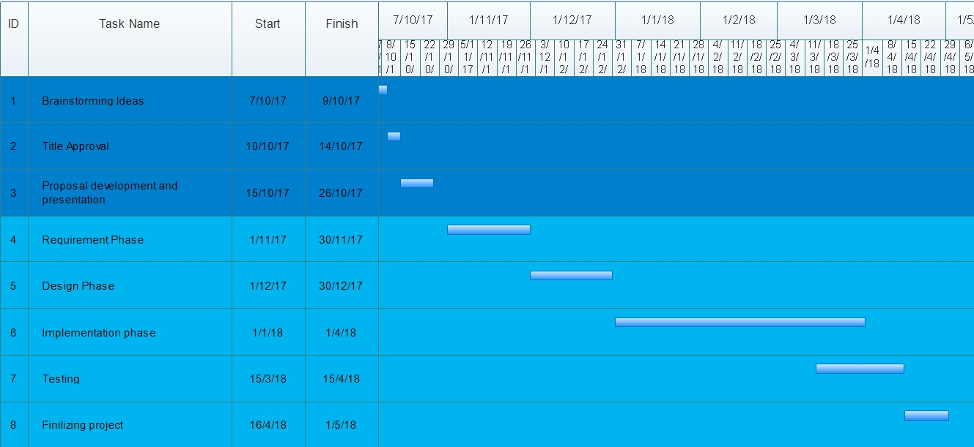

Figure 3 Gantt chart

|  |  |  |  |
| --- | --- | --- | --- |
| **Task Name** | **Duration**  **(days)** | **Start** | **Finish** |
| **Amharic book reading application using**  **Optical Character Resolution and Natural**  **Language Processing** | 245 | 10/7/2017 | 6/17/2017 |
| Brainstorming Ideas | 2 | 10/7/2017 | 10/9/2017 |
| Title Approval | 4 | 10/10/2017 | 10/14/2017 |
| Proposal Writing and Presentation | 11 | 10/15/2017 | 10/26/2017 |
| **Requirement Phase** | **30** | **11/1/2017** | **11/30/2017** |
| Gathering Project Requirement | 10 | 11/1/2017 | 11/10/2017 |
| Preparing Software Requirement Document(SRS) | 15 | 11/11/2017 | 11/25/2017 |
| Data preparation | 5 | 11/26/2017 | 11/30/2017 |
| **Design Phase** | **30** | **12/1/2017** | **12/30/2017** |
| Creating system design | 15 | 12/1/2017 | 12/15/2017 |
| Preparing Software Design Document(SDS) | 15 | 12/16/2017 | 12/30/2017 |
| **Implementation Phase** | **90** | **1/1/2018** | **4/1/2018** |
| Developing Hand Segmentation | 20 | 1/1/2018 | 1/20/2018 |
| Developing Feature Extraction | 20 | 1/20/2018 | 2/10/2018 |
| Developing Module Training | 30 | 2/10/2017 | 3/10/2018 |
| Integrating the modules | 20 | 3/10/2017 | 4/30/2018 |
| **Testing** | **30** | **3/15/2018** | **4/15/2018** |
| **Finalizing Project** | **15** | **4/16/2018** | **6/20/2018** |

Table 1 Time management Plan

### **.2 Quality Management Plan**

There are two main potential risks to the software quality. The first one is from computer vison perspective like lighting sensitivity, background, and camera position. This could be improved by using better feature extraction algorithms. The second potential risk accuracy of classification. With regards to this, we will try to train our model with as much possible data as we can.

### **1.9 .3 Communication Management Plan**

The purpose of communication plan is to define the communication requirements for the project and to apprehend how information will be distributed among the development team. Communication activities are performed by all team members and everyone will be kept informed of ongoing process of the project.

In order to achieve consistent and effective communication, standardization of documentation is used to simplify the complexities of project management communications. The team will utilize an agreed standard template for meeting agenda and meeting minutes. The meetings will be held every two days and all team members should participate. Concerning the project milestones, the team will hold a meeting with the advisor. These project milestones are expected to be presented to the project advisor so that he gives feedbacks and comments.

Meeting Agenda will be discussed one day in advance of the meeting. The first item in the agenda should be a review of action items from the previous meeting.

|  |  |  |  |  |
| --- | --- | --- | --- | --- |
| **Type of**  **Communication** | **Method / Tool** | **Frequency /Schedule** | **Information** | **Participants / Responsibilitie s** |
| **Internal Communication:** | | |  |  |
| Project Meetings | Face to face | 3 times a week | Project status, problems, risks, changed requirements | Project Team Members |
| Sharing of project data | Team Group chat | When  available | All project documentation and reports | Project Team Members |
| Sprint meeting | Face to face | Once every 3 week | Plan the next sprint, talk about issues raised in the previous sprint, project status | Project Team  Members  Advisor |
| Milestone Meetings | Face to face | Before milestones | Project status | Project Team  Members,  Advisor |
| Final Project Meeting | Face to face | Before final project | Wrap-up  Experiences | Project Mgr Project Team |
| **External Communication and Reporting:** | | |  |  |
| Project Report | Word document | As needed | Project status   * progress * risks | Advisor, Project  Team Members,  Project  Committee |

Table 2 Communication Management Plan

# **Chapter 2: Requirement Analysis**

## **2.1 Introduction**

This document is a software requirement specification (SRS) of Vision Based Finger Spelling Recognition for Ethiopian Sign Language. In this document we outline product perspective, product functions, user characteristics, general constraints and assumption and dependencies of the system to be developed. It also includes external interface requirements, use cases, non-functional requirement, inverse requirement, user interface, design constraints and logical database requirement and other requirements of the system.

## **2.2 General Description**

This section of the document describes product perspective, product functions, user characteristics, general constraints, and assumptions and dependencies.

## **2.3 Product Perspective**

Sign language is a primary tool for the deaf people to communicate with the community around them. But, most of our communities do not have the knowledge of sign language [2]. This situation leads to creation of a huge communication gap between people with hearing disabilities and the community. The problems are expressed as follows:

* **Economic cost**: - Hiring a translator is not always affordable for all people with hearing disabilities due to economic situations.
* **Privacy issue**: - Some secrets and personal information may be acquired by translators which the communicating individuals/parties may not be comfortable with sharing.
* **Lack of enough translators**: - The number of translators is very low compared to the number of people with hearing disabilities.
* Task of translating is exhausting for the translators that work in long meetings and broadcasts.

There is a system developed as part of research project titled Finger Spelling Recognition for Ethiopian Sign Language, however this project used basic Machine Learning algorithm called SVM for classification and the signer should wear a white glove in order to make it easier for hand segmentation. The points that make our system more useable are, we will use artificial neural network for classification which is more suitable for Image related classification and the signer shouldn’t have to wear a white glove.

The target goal is to overcome the above limitations by developing an automated Ethiopian sign language recognizer.

## **2.4 Product Functions**

The main function of the system is translation of Ethiopian sign language to Amharic text. This can be summarized by the figure below.

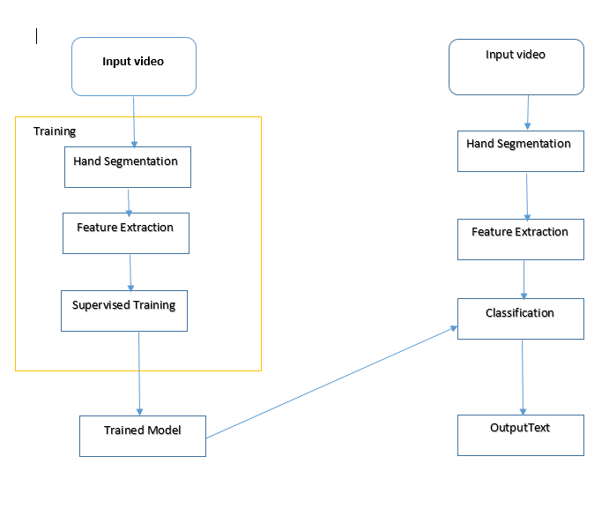

Figure 4 System Architecture

As depicted in figure*,* the system is comprised of four modules:

1. **Video** **Acquisition (Input Video)**: - The first task before proceeding to any recognition process is the acquisition of the input video in appropriate manner. We captured videos in a way that will help us to extract all necessary information.
2. **Hand Segmentation**: - The first step in hand sign language recognition is obviously to find the hand region by eliminating all the other unwanted portions in the video sequence. We will use the concept of running averages. Running average is a concept used in background extraction [3], instead of always using the first frame as a clear background, it will update it constantly, by calculating a moving average of it.

After figuring out the background model using running averages, we will use the current frame which holds the foreground object (hand in our case) in addition to the background. We calculate the absolute difference between the background model (updated over time) and the current frame (which has our hand) to obtain a difference image that holds the newly added foreground object (which is our hand). This is what Background Subtraction is all about. To detect the hand region from this difference image, we need to threshold the difference image, so that only our hand region becomes visible and all the other unwanted regions are painted as black. After thresholding the difference image, we find contours in the resulting image. The contour with the largest area is assumed to be our hand. (Counter is boundary of an object located in an image).

1. **Feature Extraction:** - The module helps to describe the salient appearance properties of the hand. Such properties are often geometrical information, e.g. positioning or orientation, which are features of the hand.

Features are components of an image which have very important information that could represent the image. The feature extraction for sign language focuses on features of the moving hands and head (in our case only hand). Important points that could describe these body parts should be extracted efficiently. In addition to this the recognition algorithms for image classifications require a numerical description of the image to be recognized.

1. **Classification**: - This module performs the task of classifying each features to the corresponding Amharic letter representation. We will develop CNN that learn features as well as the weights corresponding to each feature.

CNNs are a category of Neural Networks that have proven very effective in areas such as image recognition and classification [4]. The CNN will have a learning data set of previously labeled raw pixel generated images, which are matrixes of pixel values along with the corresponding identifiers of the Amharic letter.

## **2.5 User Characteristics**

We expect our user to have the ability to read Amharic text and he/she is not expected to have the knowledge of Ethiopia sign language.

## **2.6 General Constraints**

The following are the general constraints of the system: -

* The system will run on windows devices.
* The system user interface language is available in English and Amharic.
* Smooth background with a color that doesn't resemble skin color.

## **2.7 Assumptions and Dependencies**

In order for the system to work properly and consistently, the following assumptions and dependencies should be fulfilled.

* The input language is pure finger spelt Ethiopian sign language.
* The input camera can any mobile device camera.
* There should be a smooth background with a color that doesn't resemble skin color.

## **2.8 External Interface Requirements**

### **2.8.1 User Interfaces**

The system is a desktop based Graphical User Interface (GUI) application. The first time the application is launched, the user will be asked to start the translation as shown on Figure 2. The user can also pause and start the application by pressing a “Pause/Start” button during translation.

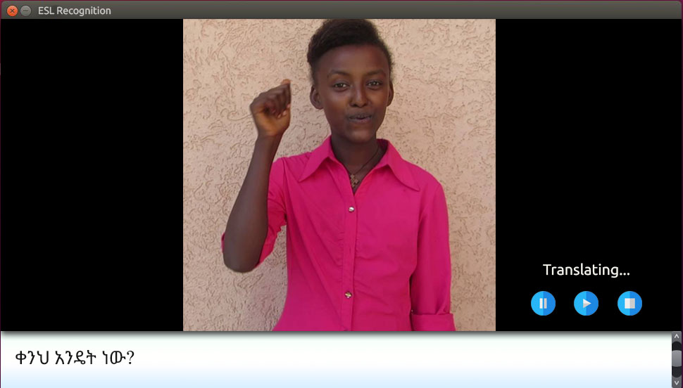

Figure 5 User Interface

### **2.8.2 Hardware Interfaces**

The system doesn’t require any other hardware interfaces other than Windows machine.

### **2.8.3 Software Interfaces**

The system doesn’t require any software interface.

### **2.8.4 Communications Interfaces**

The system doesn’t require any communication interface.

## **2.9 Functional Requirements**

Table 3 Functional Requirement 01

|  |  |
| --- | --- |
| **ID** | **FR:01** |
| **Name** | Accepting video as an input. |
| **Summary** | The system shall accept video input. |
| **Input** | The system shall use the video obtained from the mobile camera. |
| **Processing** | There is no processing involved in this requirement. |
| **Output** | The system shall output the stream of video data into a buffer. |
| **Error handling** | In case the cameras used is not functioning properly, the system shall notify the user about the specific error. |

Table 4 Functional Requirement 02

|  |  |
| --- | --- |
| **ID** | **FR:02** |
| **Name** | Segmenting hand. |
| **Summary** | The system shall segment the hand from the video obtained from the camera. |
| **Input** | The system shall read the video data obtained from a buffer. |
| **Processing** | The system shall segment the hand and extract the background. |
| **Output** | Only hand region becomes visible and put the video data into a new buffer. |
| **Error handling** | If there is no moving image in the video, the system will notify the user to move his hands. |

Table 5 Functional Requirement 03

|  |  |
| --- | --- |
| **ID** | **FR:03** |
| **Name** | Extracting features from segmented region. |
| **Summary** | The system shall extract specific features from hand sign. |
| **Input** | The system shall read video data obtained from the buffer. |
| **Processing** | The system shall extract geometrical information of the hand. |
| **Output** | A numerical description of the image (the hands). |
| **Error handling** | Whenever the system cannot extract hand features, the system will display the specific error message. |

Table 6 Functional Requirement 04

|  |  |
| --- | --- |
| **ID** | **FR:04** |
| **Name** | Classification. |
| **Summary** | The system shall analyze the numerical description in order to predict its corresponding value. |
| **Input** | Numerical values. |
| **Processing** | The system shall use its accumulated knowledge during training in order to predict the corresponding value. |
| **Output** | Percentage value with numerical representation of Amharic letter IDs. |
| **Error handling** | None. |

Table 7 Functional Requirement 05

|  |  |
| --- | --- |
| **ID** | **FR:05** |
| **Name** | Translating Ethiopian sign language to Amharic text. |
| **Summary** | The system shall search for Amharic letter mapping of the sign in a dictionary file. |
| **Input** | Percentage value with numerical representation of Amharic letter IDs. |
| **Processing** | The system shall read from a dictionary file that contains a mapping from Sign Language representation to Amharic Letter. Each Amharic letter is given unique ID. |
| **Output** | A list of Amharic letter IDs that correspond to the input signs. |
| **Error handling** | If the system cannot find a corresponding Amharic letter value for a given Sign in the dictionary file, it will notify the user that it could not translate that sign. |

Table 8 Functional Requirement 06

|  |  |
| --- | --- |
| **ID** | **FR:06** |
| **Name** | Displaying Amharic text. |
| **Summary** | The system shall display the Amharic letter representation of the corresponding sign. |
| **Input** | List of Amharic letter IDs. |
| **Processing** | The system shall run scripts that will use Amharic letter ID to display the letter. |
| **Output** | Amharic text. |
| **Error handling** | None. |

## **2.10 Use Cases**

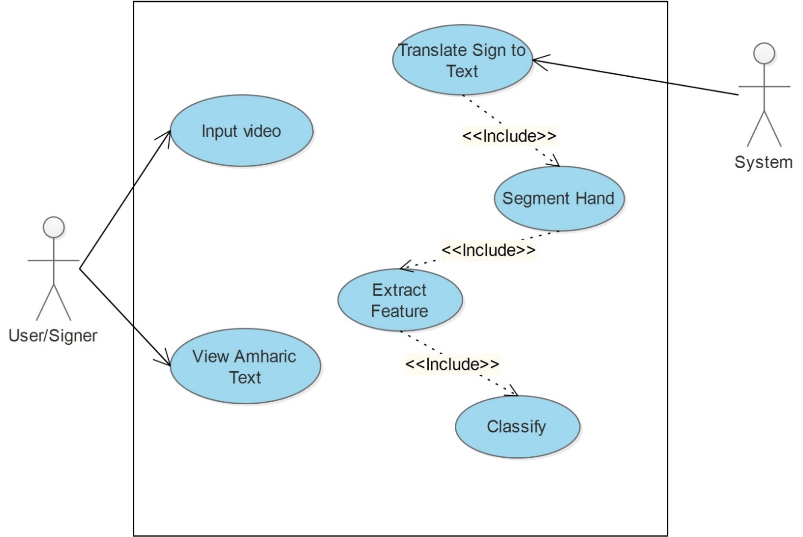

Figure 6 Use Case Diagram

### 

### **2.10.1 Use Case #1 Input Video**

**Name:** Input Video

**Actors:** Signer/User

**Description:** Enables the signer to input video of them signing

**Precondition:** The user needs camera

**Flow of events:**

1. The user clicks on Start for the application to start recognizing.
2. The user records through the camera.
3. End of the use case.

**Alternate:** camera not working properly, the system shall notify the user that the camera is not working properly.

**Post Condition:** Input video is received

### **2.10.2 Use Case #2 Segment Hand**

### **Name:** Segment Hand

**Actors:** System

**Description:** The system accepts the video data from the camera and segment the hand portion only

**Precondition:** The user succeeds in inputting video through the camera

**Flow of events:**

1. The system accepts the video data from the camera attached to the machine on which it is running on.
2. It then computes the running average to get the background.
3. It calculates the absolute difference between the background model (updated over time, obtained from step 2) and the current frame (which has our hand).
4. It thresholds the image difference.
5. It then finds counters in the resulting image.
6. End of use case.

**Alternate:**

1. The system cannot get video data from the camera.

* The system notifies the user to check if the camera is working and to try again.

1. The system cannot detect the background because there a movement in the background.

* The system notifies the user about the error and to try again by sitting in front of a static background.

**Post Condition:** Hand segmented from the video

### **2.10.3 Use Case #3 Extract Feature**

**Name:** Extract feature

**Actors:** System

**Description:** The System accepts the segmented hand video data and extract geometrical information of the hand

**Precondition:** Hand must be segmented

**Flow of events:**

1. The System looks at the segmented hand.
2. It generates raw pixel values for the segmented hand.
3. It computes the center of mass of the segmented hand.
4. It analyses the direction and distance of movement of the hand.
5. It assigns the corresponding vowel representation of the movement.
6. It then sends the image description to classifier.
7. End of use case.

**Alternate:** None

**Post Condition:** extracted features are sent to Predictor (trained model)

### **2.10.4 Use Case #4 Classification**

**Name:** Classification

**Actors:**  System

**Description:** The classifier accepts the extracted features from feature extractor and make a prediction about the sign

**Precondition:** The feature extractor has successfully extracted features

**Flow of events:**

1. The System outputs the extracted features to the classifier.
2. The classifier receives the output from features extractor using API calls.
3. The classifier makes its prediction by detecting some kind of pattern from the extracted features.
4. End of use case.

**Alternate:** An error occurs during transmission of the features to the classifier

The classifier sends an error message notifying the system that an error has occurred.

**Post Condition:** The Classifier successfully classified the images.

### **2.10.5 Use Case #5 Translate sign to text**

**Name:** Translate sign to text

**Actors:** System

**Description:** The system maps the classified images to the corresponding Amharic letter representation

**Precondition:** The classifier successfully classified the images

**Flow of events:**

1. The system receives the representation of the classified image.
2. The system then maps the Amharic letter representation from a dictionary file.
3. The system then displays the Amharic letter representation.
4. End of use case.

**Post Condition:** Segmented Amharic text displayed on the screen

## 

## **2.11 Non-Functional Requirements**

### **2.11.1 Performance**

There will always be delays during translation process whether it is done by a human or a machine. This system will also have delays in translating sign language to text as it has to accept video input, analyze it and translate it to appropriate text representation. Hence, there is some level of acceptable delay in getting output from this system. However, the time delay of a translating a given word should not exceed 5 seconds for the system to be usable properly.

The translation of the system should be reliable in that it should provide accurate translation of sign language text. We will perform different evaluation method to calculate our systems accuracy in order to know if it is reliable or not.

### **2.11.2 Maintainability**

The system will be developed by taking extensibility in mind. To ensure the code we write to develop the system is reusable, we will follow the SOLID principles. The code will also be available on GitHub, hence, anyone who is interested can extend and contribute further.

## **2.12 Inverse Requirements**

The Sign to Amharic text translator **CANNOT** be used for the following scenarios:

* For translating Amharic Speech to Sign language.
* For translation Amharic text to sign language.
* Recognizing gender of the signer based on his/her sign/face.

## **2.13 Design Constraints**

There are two design constraints that must be taken into account for the development of the system.

The first one is constraints related to the input of the video.

* Environmental concerns (e.g. lighting sensitivity, background, and camera position)
* Occlusion (e.g. some or all fingers, or an entire hand can be out of the field of view)
* Sign boundary detection (when a sign ends and the next begins)
* Co-articulation (when a sign is affected by the preceding or succeeding sign.

The second constraint is the recognition of the signs using the CNN.

* Processing power: - The CNN requires heavy processing power for fast computation.
* Training Data: - The accuracy is limited by the amount of training data.

## **2.14 Logical Database Requirements**

This is system doesn’t use a database, hence, it doesn’t have any logical database requirements.

## **2.15 Other Requirements**

***Packaging Requirements***

The system will be distributed in an installer package that will install it on the major platforms. However, as an alternative, we will provide the code along with build files that will be used by advanced users to build the system by themselves.

***Legal Requirements***

The system will be distributed under GPLv3 license. The reason we chose this license among other open-source licenses is that it imposes a requirement on users who wish to distribute a software licensed under GPL to license their distribution under GPLv3 too. We believe this encourages anyone who wants to build upon or extend our system to make their product open-source, thereby, contributing to the development of work in the area of Sign Language translation.

## **2.16 Change Management Process**

Requirements may change during development course of the project. This changes are applied only after going through the following change management process.

* A team member proposes a requirement change. The proposed change should include scope, reason and impact for the change.
* The pros and cons of the change will be examined by the team.
* The requirement will be submitted to advisor for approval.
* The advisor will decide if the change is relevant.
* The requirement change will be added to this document.

# **Chapter 3: SYSTEM DESIGN**

## **3.1 General Overview**

Currently, sign language interpreters/translators do the (manual) job of translating from a spoken language to sign language and vice versa. The proposed system is to develop a system that translates Ethiopian sign language to Amharic text.

The system is designed for any one who can read Amharic text. Its major goal is to reduce the communication barrier between hearing imparied person and hearing person.

As depicted in the Figure 1, the system consists of four modules.

1. **Video** **Acquisition (Input Video)**: - The first task before proceeding to any recognition process is the acquisition of the input video in appropriate manner.

2*.* **Hand Segmentation:** - this module handles the task of segmenting the hand.

3. **Feature Extraction:** -The module helps to describe the salient appearance properties of the hand. Such properties are often geometrical information, e.g. positioning or orientation, which are features of the hand.

4. **Classification: -** This module performs the task of classifying each features to the corresponding Amharic letter representation.

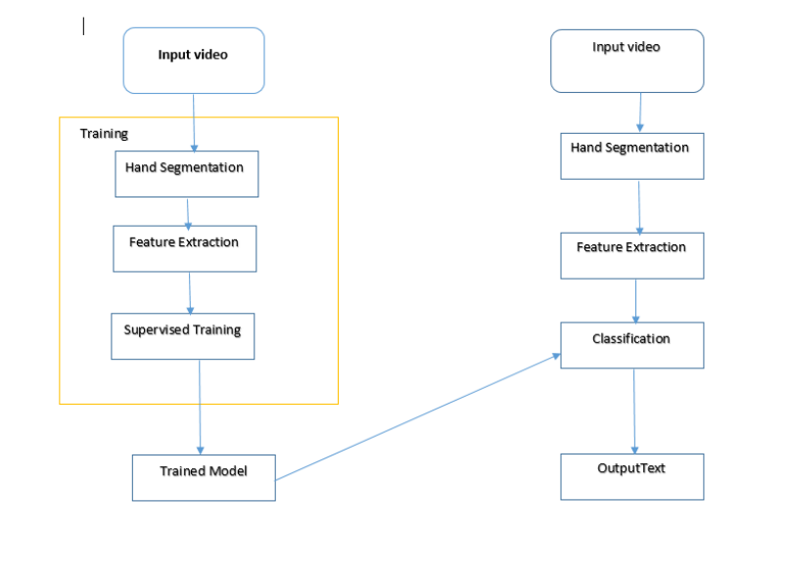

Figure 7 system architecture for FSRFEthSL

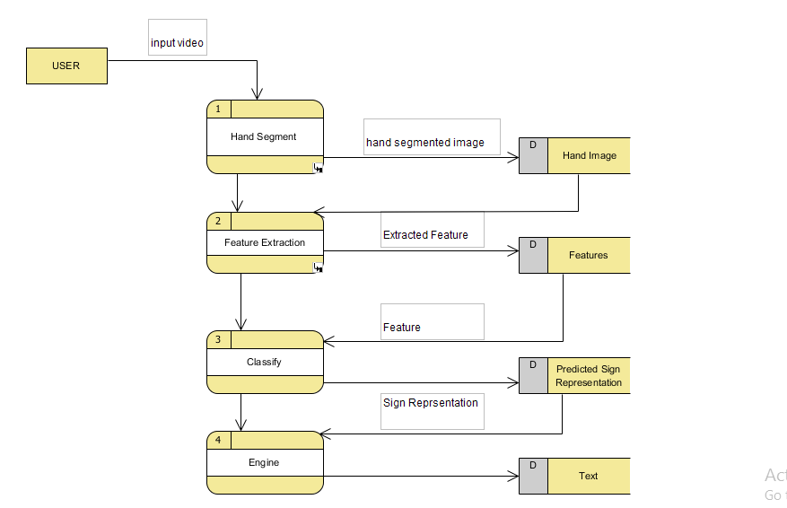

Figure 8 high-level context diagram for FSRFEthSL

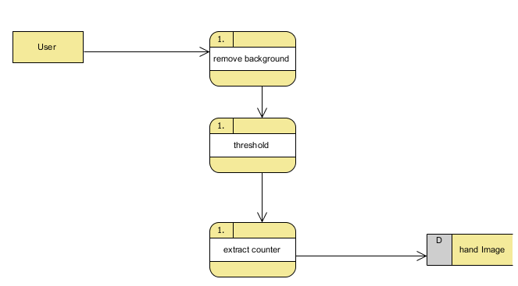

Figure 9 data flow diagram for FSRFEthSL

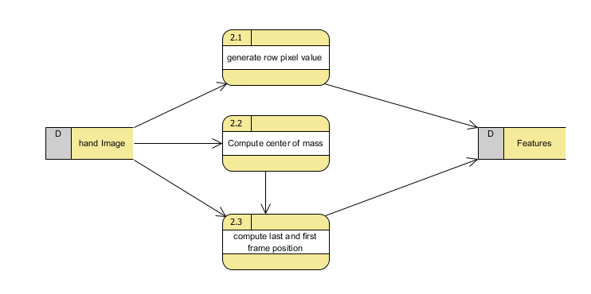

Figure 10 level 2 data flow diagram for FSRFEthSL

## **3.2** **Development Methods & Contingencies**

The system is developed on an Object Oriented Approach. We also use the following method and tools described below to develop the system.

* **OpenCV** is one of the most popular libraries used to develop Computer Vision applications. It enables us to run many different Computer Vision algorithms in real time. It has been around for many years, and it has become the standard library in this field. One of the main advantages of OpenCV is that it is highly optimized and available on almost all the platforms.
* **TensorFlow** is an open-source software library for machine learning across a range of tasks. It is a symbolic math library, and also used as a system for building and training neural networks to detect and decipher patterns and correlations, analogous to human learning and reasoning.
* **Python** programming language for development purpose.

## **3.3 System Architecture**

### **3.3.1 Subsystem decomposition**

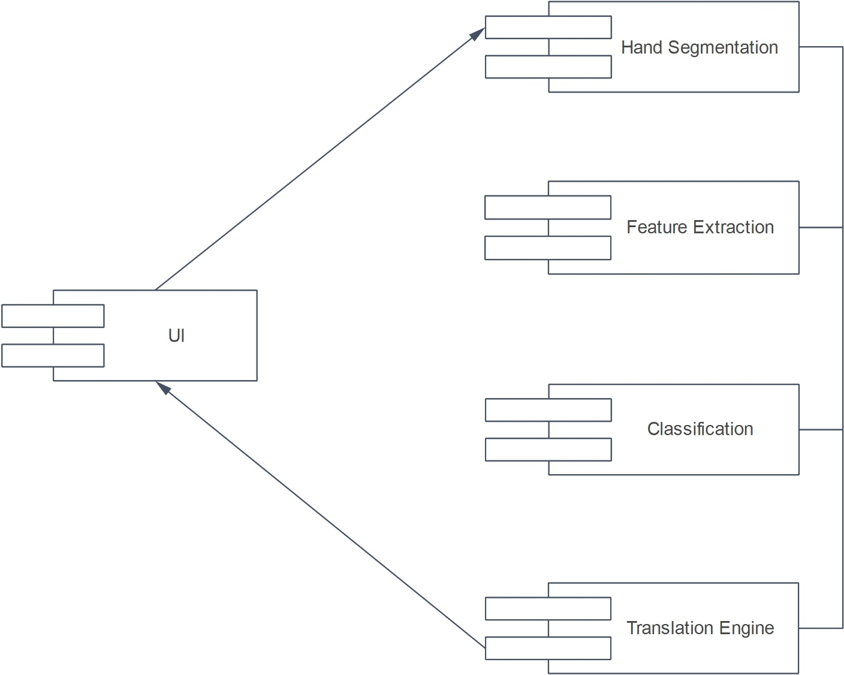

Figure 11 Component diagram for FSRFEthSL

### **3.3.2 Hardware/software mapping**

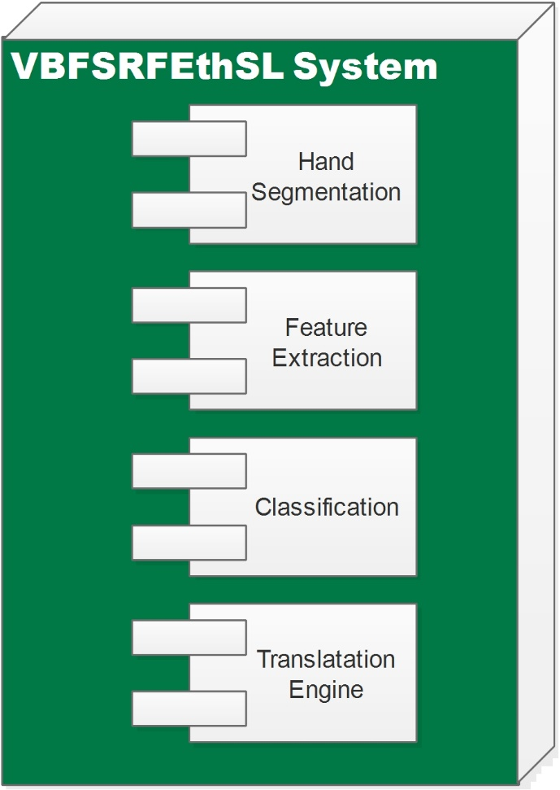

Figure 12 Deployment Diagram for FSRFEthSL

## **3.4 Object Model**

### **3.4.1 Class Diagram**

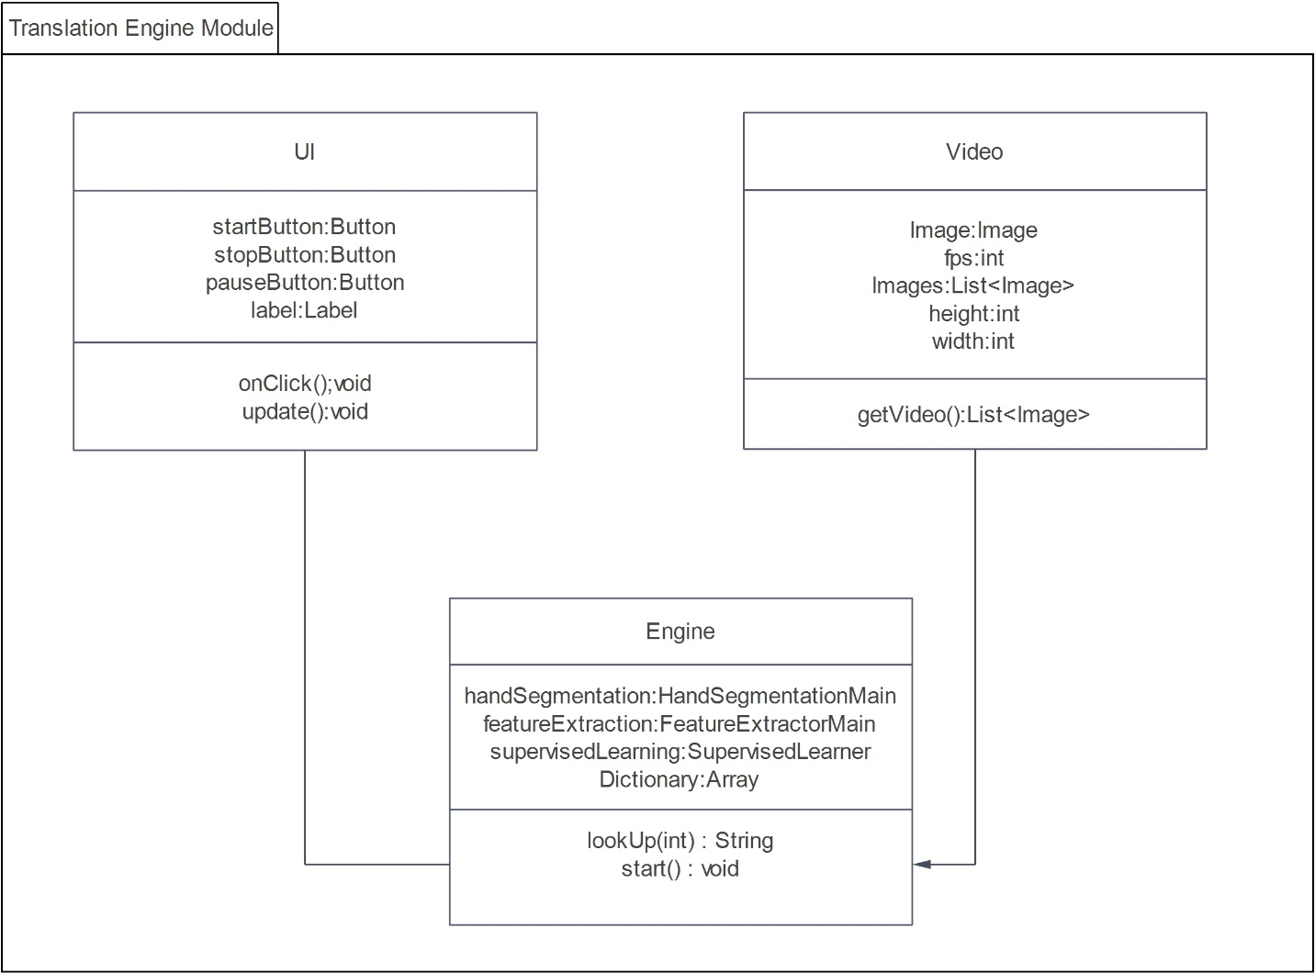

Figure 13 Translation Engine Module class Diagram for FSRFEthSL

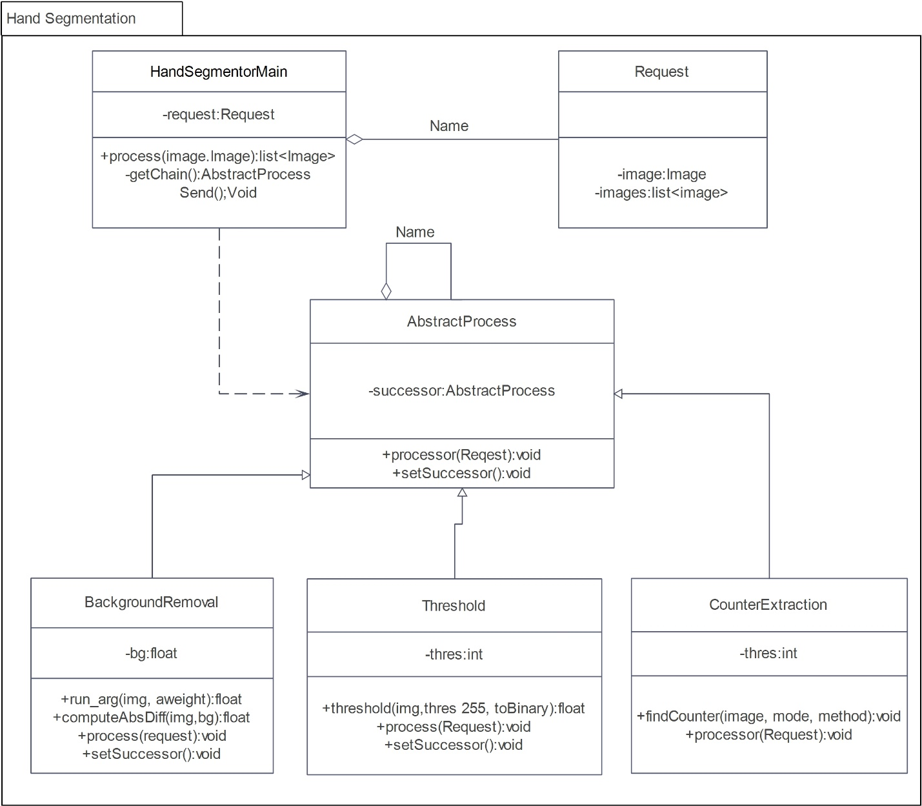

Figure 14 Hand Segmentation class Diagram for FSRFEthSL

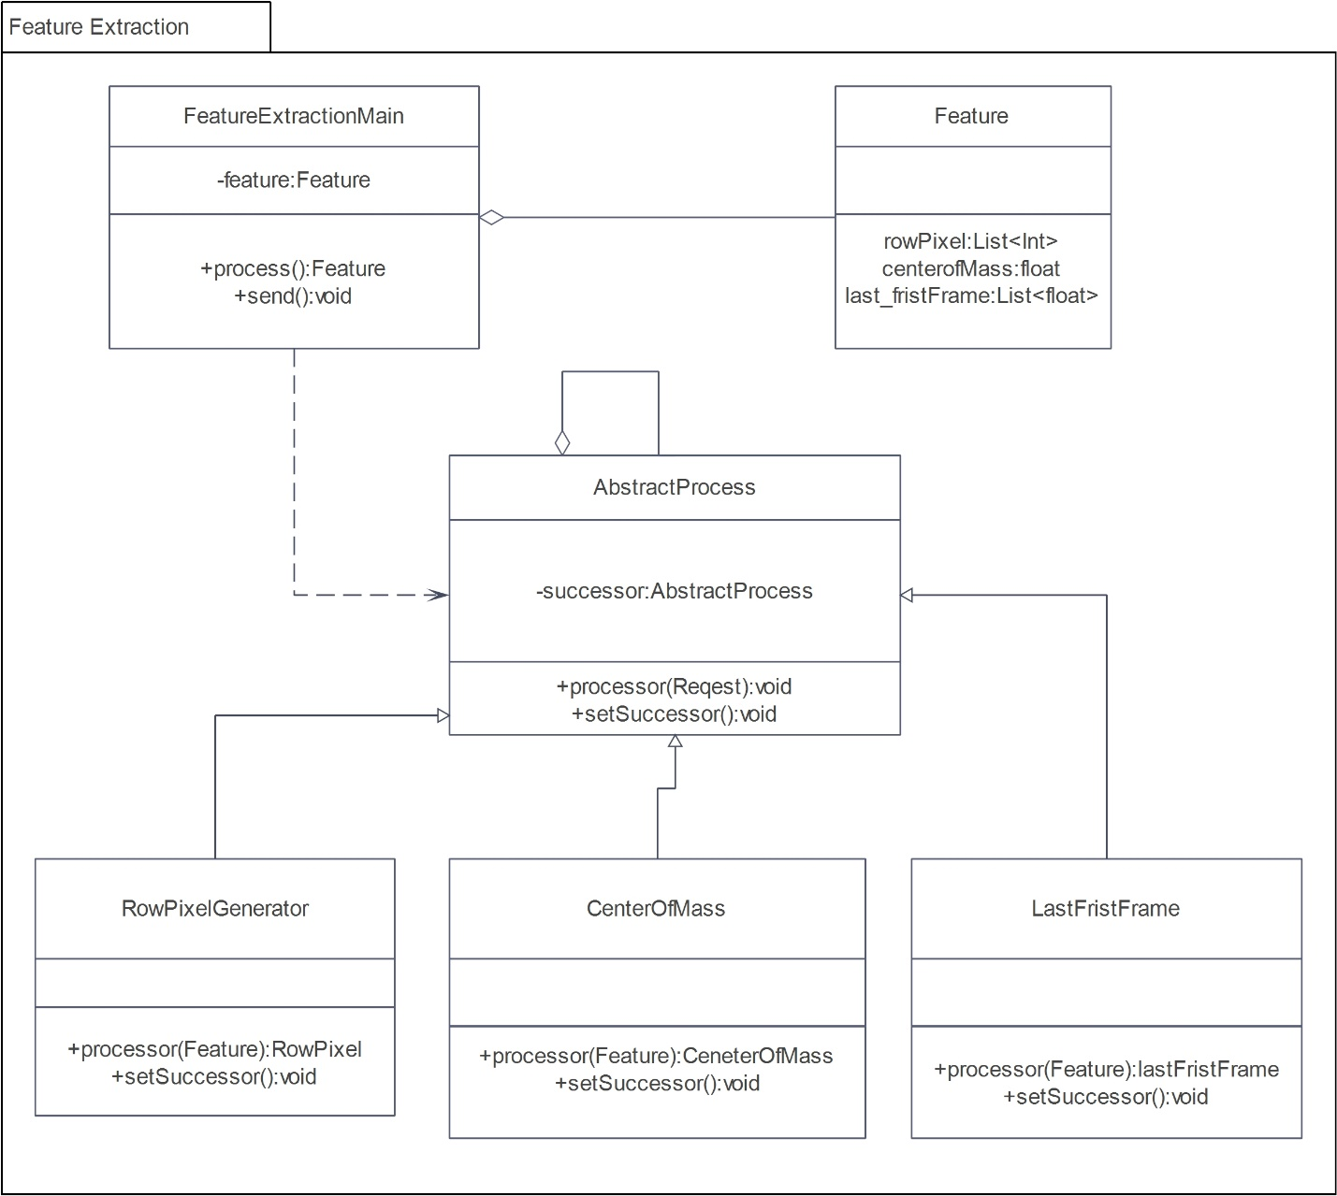

Figure 15 feature extraction class diagram for FSRFEthSL

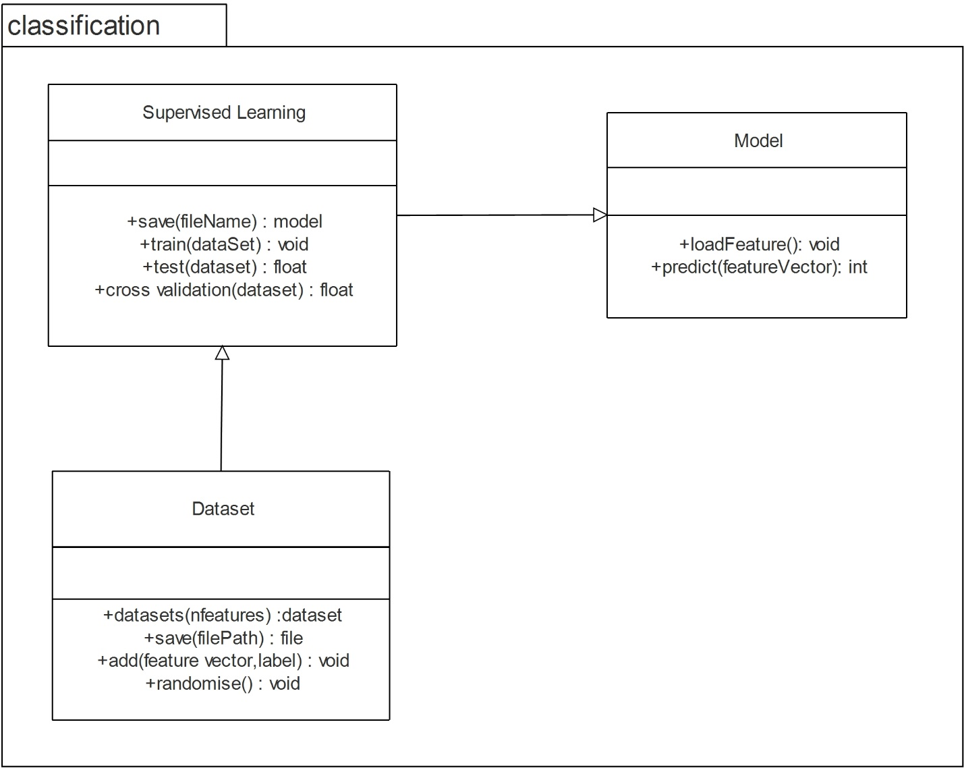

Figure 16 Classification class diagram for FSRFEthSL

### **3.4.2 Sequence Diagram**

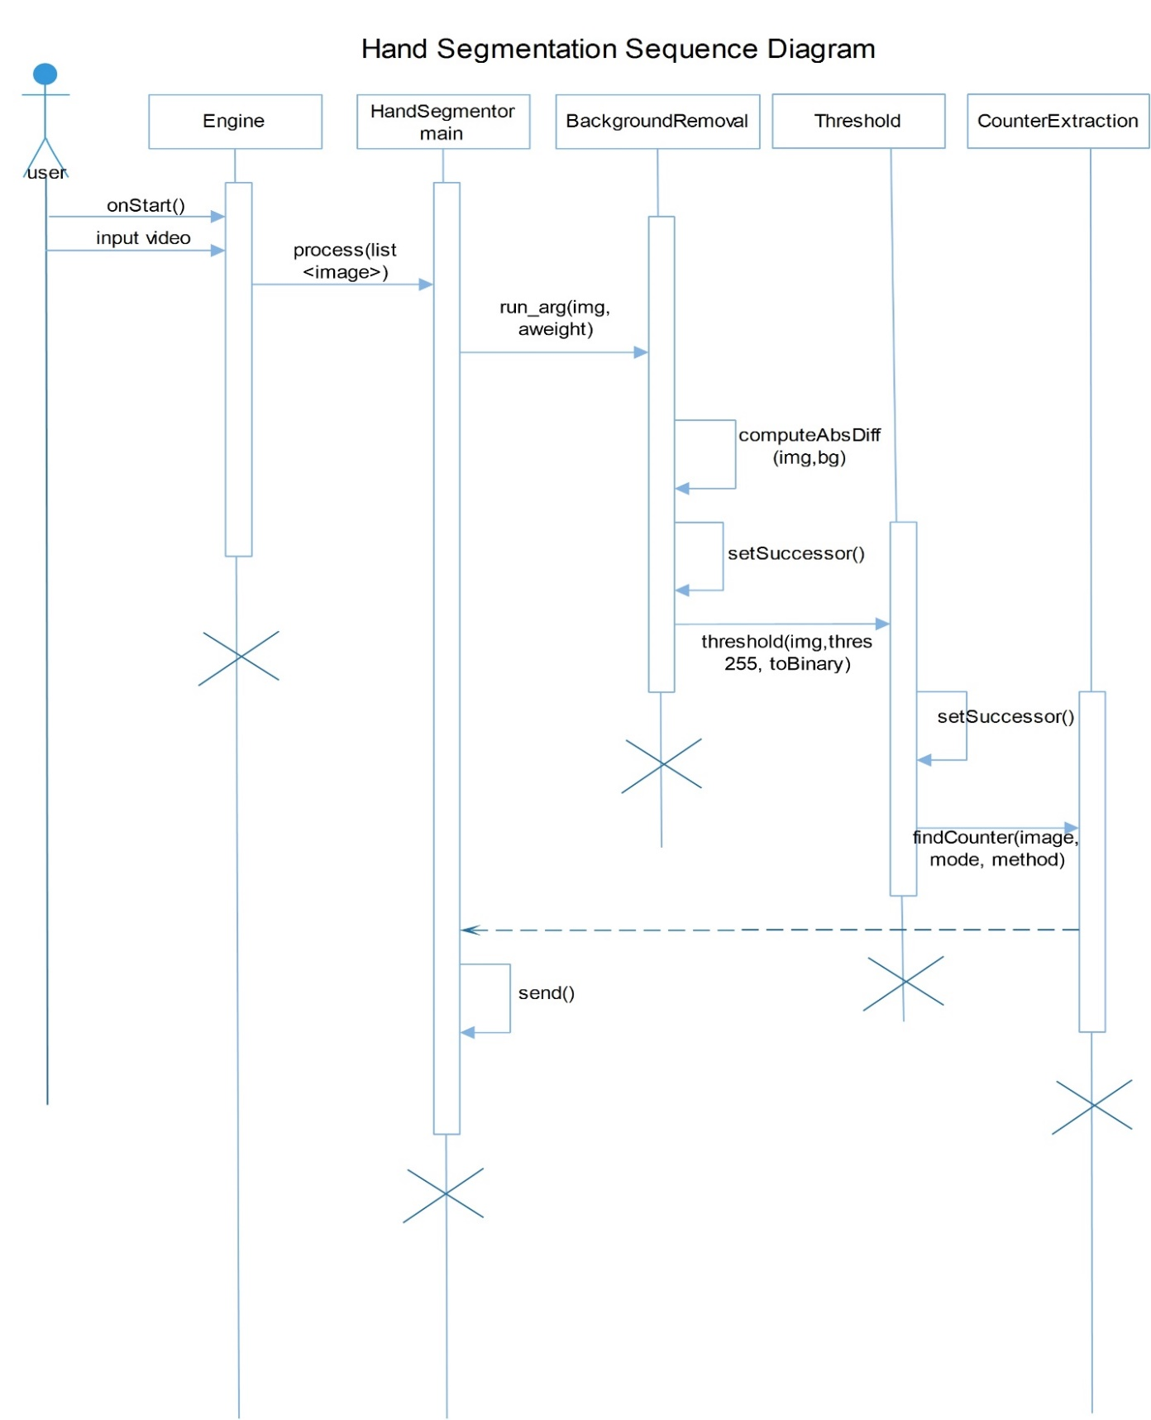

Figure 17 hand segmentation sequence diagram for FSRFEthSL

# C:\Users\Yohannes\Desktop\AAAA project final SRS\edraw\nati\feature00000.jpg

Figure 18 Feature extraction sequence diagram for FSRFEthSL

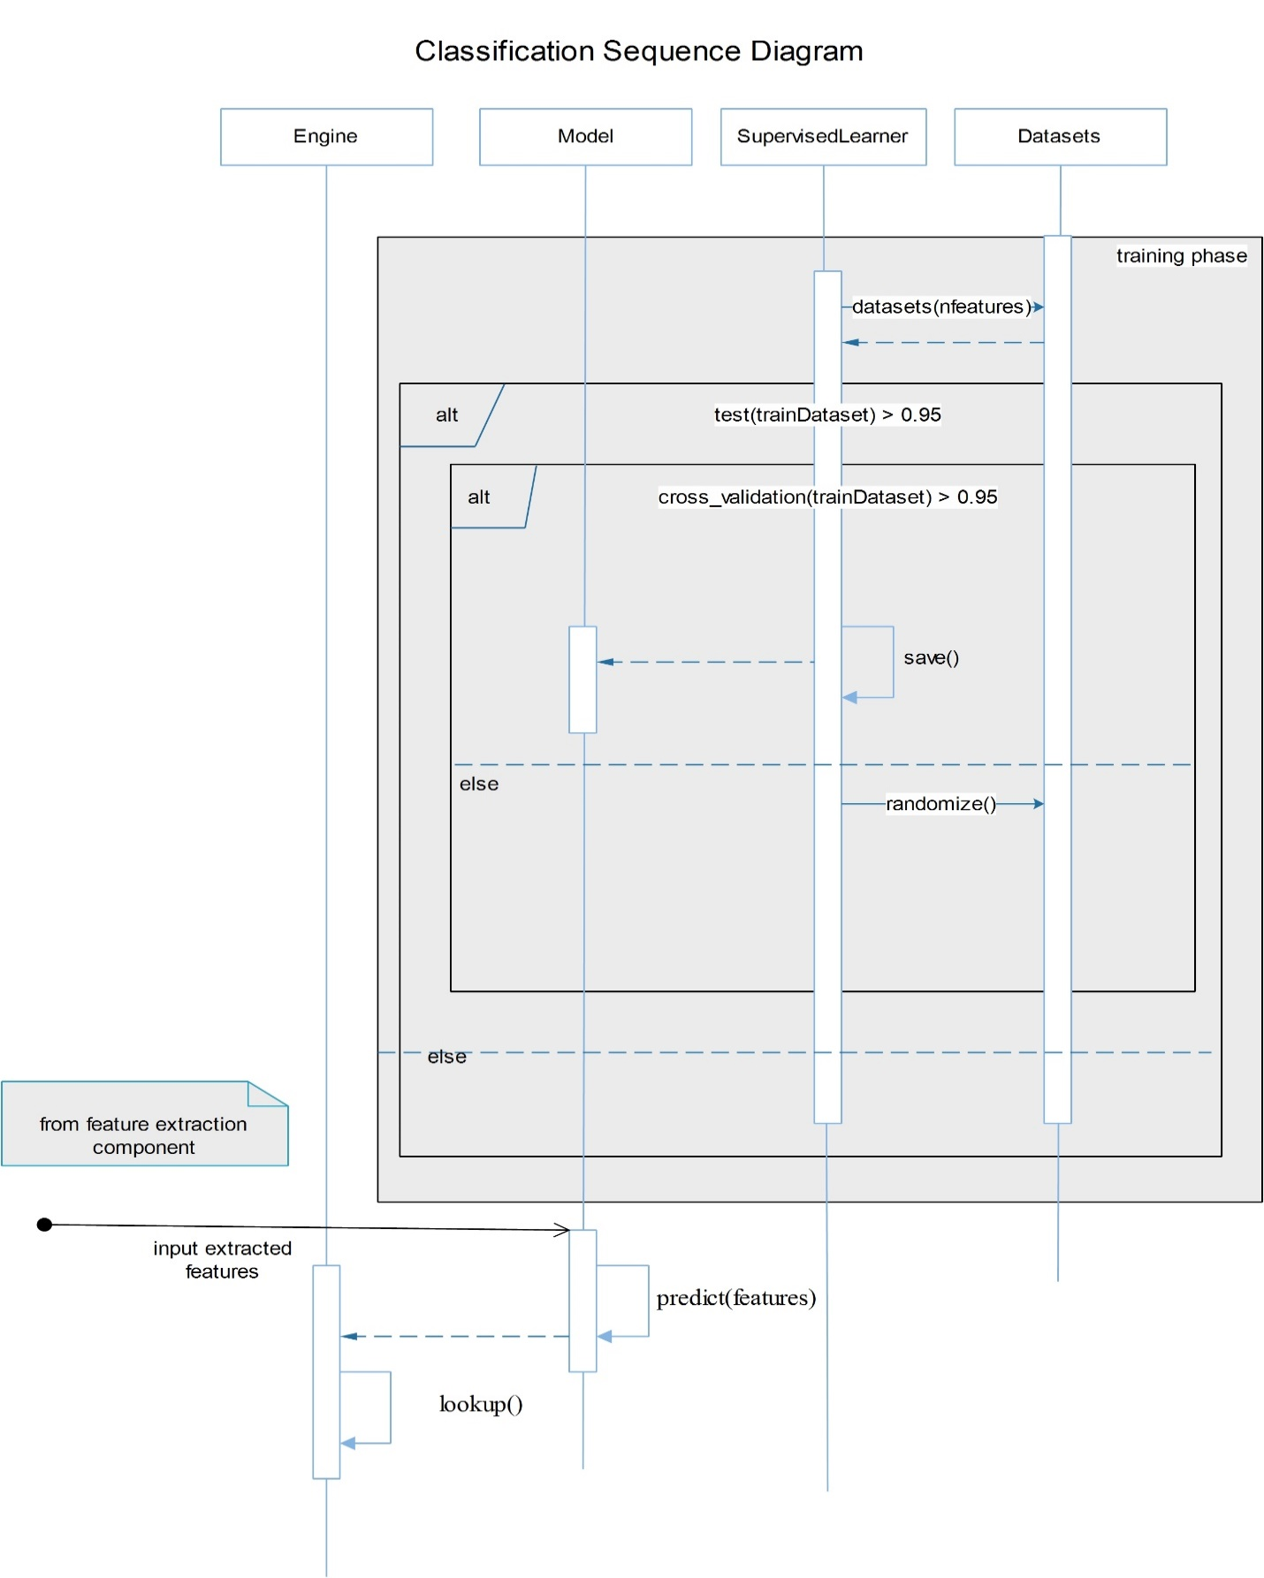

Figure 19 Classification sequence diagram for FSRFEthSL

## **3.5 Detailed Design**

Table 9 UI class

|  |
| --- |
| **UI** |
| - startButton:Button  - stopButton:Button  - pauseButton:Button  -label:Label |
| +onClick():void  +update():void |

Table 10 Attributes description for UI class

|  |  |  |  |
| --- | --- | --- | --- |
| Attribute | Type | Visibility | Invariant |
| startButton | Button | Private |  |
| stopButton | Button | Private |  |
| pauseButton | Button | Private |  |
| label | label | Private |  |

Table 11 Operation description for UI class

|  |  |  |  |  |  |
| --- | --- | --- | --- | --- | --- |
| Operation | Visibility | Return type | Argument | Pre-Condition | Post Condition |
| onClick | Public | void | - | - | Will be applied to the buttons |
| update | Public | void | - | - | Updates the label whenever a new sign is recognized. |

Table 12 Video class

|  |
| --- |
| **Video** |
| -Image:Image  -Images:list<Images>  -fbs:int  -height:int  -width:int |
| +getVideo(): List<Image> |

Table 13 Attributes description for Video class

|  |  |  |  |
| --- | --- | --- | --- |
| Attribute | Type | Visibility | Invariant |
| Image | Image | Private | Image <> NULL and must contain a matrix of vertices to be preprocessed. |
| Images | List<Image> | Private | Images contains lists of segmented vertices after preprocessing |
| fbs | Int | Private | Number of images per second |
| height | Int | Private |  |
| Width | Int | Private |  |

Table 14 Operation description for Video class

|  |  |  |  |  |  |
| --- | --- | --- | --- | --- | --- |
| Operation | Visibility | Return type | Argument | Pre-Condition | Post Condition |
| getVideo | Public | List<Image> | - | - | Initiates webcam loads the images |

Table 15 Engine class

|  |
| --- |
| **Engine** |
| -handSegmentation:HandSegmentation  -featureExtraction:FeatureExtractionMain  -supervisedLearner:SupervisedLearner  -dictionary:Array |
| +start():void  +lookup(int) : char |

Table 16 Attributes description for Engine class

|  |  |  |  |
| --- | --- | --- | --- |
| Attribute | Type | Visibility | Invariant |
| handSegmentation | HandSegmentation | Private | Contain the object that perform hand segmentation process |
| featureExtraction | FeatureExtractionMain | Private | Contain the object that perform feature extraction process |
| supervisedLearner | SupervisedLearner | Private | Contain the object that perform the classification process |
| dictionary | Array | Private | Contain array of Amharic letter with their representation |

Table 17 Operation description for Engine class

|  |  |  |  |  |  |
| --- | --- | --- | --- | --- | --- |
| Operation | Visibility | Return type | Argument | Pre-Condition | Post Condition |
| lookup | Public | Char | int | Classification module should classify the image | Lookup the Amharic letter corresponding to its integer |
| Start | Public | Void |  |  | Launches the application |

4.2 Hand Segmentation package

Table 18 Request class

|  |
| --- |
| **Request** |
| -Image:Image  -Images:list<Images> |

Table 19 Attributes description for Request class

|  |  |  |  |
| --- | --- | --- | --- |
| Attribute | Type | Visibility | Invariant |
| Image | Image | Private | Image <> NULL and must contain a matrix of vertices to be preprocessed. |
| Images | List<Image> | Private | Images contains lists of segmented vertices after preprocessing |

Table 20 BackgroundRemoval class

|  |
| --- |
| **BackgroundRemoval** |
| -background : float |
| +run_arg(img, aweight):float  +computeAbsDiff(img,bg):float  +process(request):void  +setSuccessor():void |

Table 21 Attributes description for BackgroundRemoval class

|  |  |  |  |
| --- | --- | --- | --- |
| Attribute | Type | Visibility | Invariant |
| background | Float | Private | background <> NULL contains background value to label vertices as background |

Table 22 Operation description for BackgroundRemoval class

|  |  |  |  |  |  |
| --- | --- | --- | --- | --- | --- |
| Operation | Visibility | Return type | Argument | Pre-Condition | Post Condition |
| run_arg | Public | float | img, aweight | A Image object must be provided | Calculate the moving average of the background |
| computeAbsDiff | Public | float | img,bg | The Background moving average must be calculate | Calculates the difference between the background and the new frame to find the new foreground object |
| process | Public | void | Request | A matrix containing vertices to be segmented must be provided in the request object | Background removed set of vertices will be provided to the next stage. |
| setSuccessor | Public | void | - | - | The next preprocessor object will be assigned. |

Table 23 Threshold class

|  |
| --- |
| **Threshold** |
| - thres:int |
| +threshold(img,thres 255, toBinary):float  +process(Request):void  +setSuccessor():void |

Table 24 Attributes description for Threshold class

|  |  |  |  |
| --- | --- | --- | --- |
| Attribute | Type | Visibility | Invariant |
| Thres | Int | Private | TRESHOLD <> NULL contains the threshold value to segment a set of vertices |

Table 25 Operation description for Threshold class

|  |  |  |  |  |  |
| --- | --- | --- | --- | --- | --- |
| Operation | Visibility | Return type | Argument | Pre-Condition | Post Condition |
| threshold | Public | float | img,thres 255, toBinary | A Image object must be provided | Threshold the images using thres as a maximum value |
| process | Public | void | Request | A matrix containing vertices to be segmented must be provided in the request object | threshed set of vertices will be provided to the next stage. |
| setSuccessor | Public | void | - | - | The next preprocessor object will be assigned. |

Table 26 CounterExtraction class

|  |
| --- |
| **CounterExtraction** |
|  |
| +findCounter(image, mode, method):void  +processor(Request):void |

Table 27 Attributes description for CounterExtraction class

|  |  |  |  |
| --- | --- | --- | --- |
| Attribute | Type | Visibility | Invariant |
| Thres | Int | Private | TRESHOLD <> NULL contains the threshold value to segment a set of vertices |

Table 28 Operation description for CounterExtraction class

|  |  |  |  |  |  |
| --- | --- | --- | --- | --- | --- |
| Operation | Visibility | Return type | Argument | Pre-Condition | Post Condition |
| findCounter | Public | Void | image, mode, method | A Image object must be provided | Calculates largest area counters assumed to be hand |
| process | Public | void | Request | A matrix containing vertices to be segmented must be provided in the request object | set of vertices containing the segmented hand will be provided to the next stage. |

4.3 Feature Extractor package

Table 29 FeatureExtractionMain class

|  |
| --- |
| **FeatureExtractionMain** |
| +feature: Feature |
| +process (): Feature  +send ():void |

Table 30 Attributes description for FeatureExtractionMain class

|  |  |  |  |
| --- | --- | --- | --- |
| Attribute | Type | Visibility | Invariant |
| feature | Feature | Public | feature <> NULL contains a single feature used by classification algorithm. |

Table 31 Operation description for Mobile Client class

|  |  |  |  |  |  |
| --- | --- | --- | --- | --- | --- |
| Operation | Visibility | Return type | Argument | Pre-Condition | Post Condition |
| process | Public | void | . | The specific feature expected to be extracted is known | This method calls the process methods of each feature extractor object and will provide a feature object containing all the required features |
| send | Public | void | . | The feature object is created | Send the feature to classification |

Table 32 Feature class

|  |
| --- |
| **Feature** |
| -rowPixel: array  -centerOfMass: float  -lastFirstFrame: float |

Table 33 Attributes description for Feature class

|  |  |  |  |
| --- | --- | --- | --- |
| Attribute | Type | Visibility | Invariant |
| rowPixel | Int | Private | Array of pixel for segmented hand |
| centerOfMass | Float | private | Center of mass for segmented hand |

Table 34 AbstractProcess

|  |
| --- |
| **AbstractProcess** |
| -successor: AbstractProcess |
| +processor (Request): void  +setSuccessor ():void |

Table 35 Attributes description for Mobile Client class

|  |  |  |  |
| --- | --- | --- | --- |
| Attribute | Type | Visibility | Invariant |
| successor | AbstractProcess | Public | - successor <> NULL contains the next operation in the preprocessing chain |

Table 36 Operation description for Mobile Client class

|  |  |  |  |  |  |
| --- | --- | --- | --- | --- | --- |
| Operation | Visibility | Return type | Argument | Pre-Condition | Post Condition |
| processor | Public | void | . |  | Provides declaration for process method |
| setSuccessor | Public | void | . |  | Provides declaration for setSuccessor method |

Table 37 RowPixelGenerator

|  |
| --- |
| **RowPixelGenerator** |
|  |
| +processor (feature): RowPixel  +setSuccessor ():void |

Table 38 Attributes description for RowPixelGenerator class

|  |  |  |  |
| --- | --- | --- | --- |
| Attribute | Type | Visibility | Invariant |
|  |  |  | - |

Table 39 Operation description for RowPixelGenerator class

|  |  |  |  |  |  |
| --- | --- | --- | --- | --- | --- |
| Operation | Visibility | Return type | Argument | Pre-Condition | Post Condition |
| processor | Public | RowPixel | . | Matrices representing the segmented hand | Each values of vertices are extracted |
| setSuccessor | Public | void | . |  | The next preprocessor object will be assigned. |

Table 40 CenterOfMass

|  |
| --- |
| **CenterOfMass** |
|  |
| +processor (Feature): CenterOfMass  +setSuccessor ():void |

Table 41 Operation description for CenterOfMass class

|  |  |  |  |  |  |
| --- | --- | --- | --- | --- | --- |
| Operation | Visibility | Return type | Argument | Pre-Condition | Post Condition |
| processor | Public | CenterOfMass | . |  | Compute center of mass |
| setSuccessor | Public | void | . |  | The next preprocessor object will be assigned. |

Table 42 LastFirstFrame class

|  |
| --- |
| **LastFirstFrame** |
|  |
| +processor (Feature): LastFirstFrame  +setSuccessor ():void |

Table 43 Operation description for LastFirstFrame class

|  |  |  |  |  |  |
| --- | --- | --- | --- | --- | --- |
| Operation | Visibility | Return type | Argument | Pre-Condition | Post Condition |
| processor | Public | void LastFirstFrame | . |  | Compute the first and last frame position of the segmented hand images |
| setSuccessor | Public | void | . |  | The next preprocessor object will be assigned. |

4.4 Classification Package

Table 44 SupervisedLearner class

|  |
| --- |
| **SupervisedLearner** |
|  |
| +save(filename):Model  +train(dataset):Void  +test(dataset):float  +cross_validation(dataset):float |

Table 45 Operation description for SupervisedLearner class

|  |  |  |  |  |  |
| --- | --- | --- | --- | --- | --- |
| Operation | Visibility | Return type | Argument | Pre-Condition | Post Condition |
| save | Public | Model | Filename | The model should have an accuracy value of 0.95 | Model has been save successfully and ready to deployed |
| train | Public | void | Dataset | - | Learn patterns from the training dataset |
| test | Public | Float | Dataset | The model has been trained on train dataset | Helps to us to evaluate the accuracy on test dataset |
| cross_validation | Public | Float | Dataset | - | Helps us to evaluate accuracy on the whole dataset |

Table 46 Dataset class

|  |
| --- |
| **Dataset** |
|  |
| +datasets(nfeatures):Dataset  +save(filePath):File  +add(featureVector, Label):void  +randomise():void |

Table 47 Operation description for Dataset class

|  |  |  |  |  |  |
| --- | --- | --- | --- | --- | --- |
| Operation | Visibility | Return type | Argument | Pre-Condition | Post Condition |
| datasets | Public | Dataset | nFeatures | - | Initiates the datasets of object |
| Save | Public | File | Dataset | - | Saves the datasets to be loaded in the SupervisedLearner object |
| add | Public | Float | featureVector, Label | Dataset should exist | Adds new feature to datasets |
| randomise | Public | Void | - | Datasets should exist | Randomize the datasets |

Table 48 Model class

|  |
| --- |
| **Model** |
|  |
| +load_feature():void  +predict(features):Int |

Table 49 Operation description for SupervisedLearner class

|  |  |  |  |  |  |
| --- | --- | --- | --- | --- | --- |
| Operation | Visibility | Return type | Argument | Pre-Condition | Post Condition |
| load_dataset | Public | Model | - | - | Loads the features extracted from segmented hand |
| predict | Public | void | features | Features should be loaded | Classify the features as Amharic letter representation |

# **Chapter 5: Testing**

## 5.1 Introduction

Software testing is an activity to check whether the actual results match the expected results to ensure the software system is defect free. It involves execution of a software component or system component to evaluate one more property of interest

## 5.2 Features to be tested/not to be tested

### 5.2.1 Features to be tested

Functional requirements to be tested:

|  |  |
| --- | --- |
| **Features** | **Level of Risk** |
| Hand Segmentation | High |
| Feature Extraction | High |
| Classification | High |

### 5.2.2 Features not to be tested

Every feature is tested

## 5.3. Pass/Fail criteria

Every feature will be examined and the success or fail will be measured in the following manner based on the output: -

If the actual output and the expected result are the same the pass/fail criteria is satisfied (success), if the actual output and the expected result are different the pass/fail criteria fails

## 5.4. Approach/Strategy

Every member of the group will test the whole system and its components separately. Two testing approaches where used, these are unit testing and integration testing.

**Unit Test** is a test written by the programmer to verify that a relatively small piece of code is doing what is intended to do. Every components of the system have been first been tested before being used in the whole system.

**Integration Test is** done to demonstrate that different pieces of the system work together. Integration test cover the whole application. Integration test for our system has been done by all members of the group.

No specific test tools are available for this project

# 

# **Chapter 6: User Manual**

EthSL is a desktop application used for translating finger spelling of Ethiopian sign language to text.

## 6.1 scope

The manual covers the following:

* How to How to start the system
* How to write consonants?
* How to write vowels?
* Space and Delete

## 6.2 Installation and configuration

**Pre-requirement**

The software is compatible with the following Windows Operating Systems.

* Windows 7, 8, 10

**Installation Procedure**

* + - 1. Open EthSL setup file

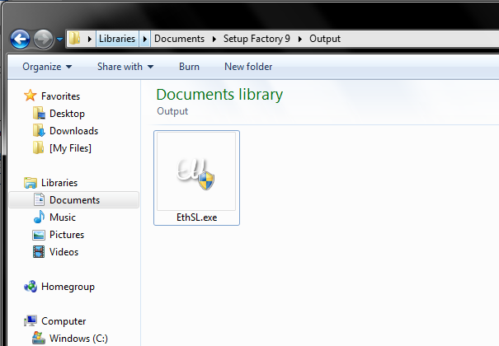

* + - 1. Follow Instructions on the setup

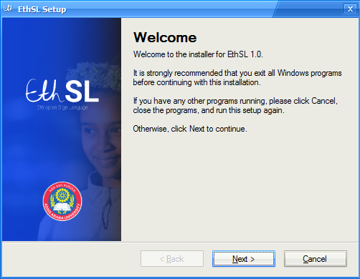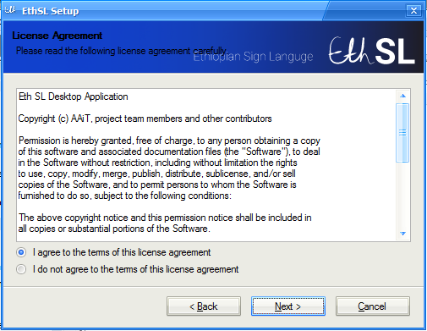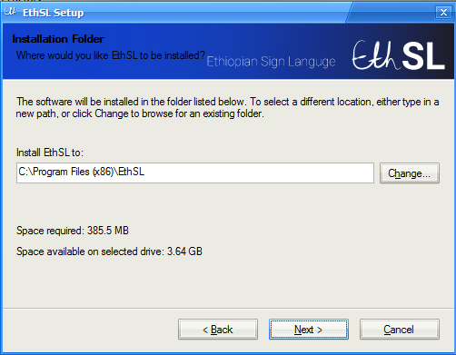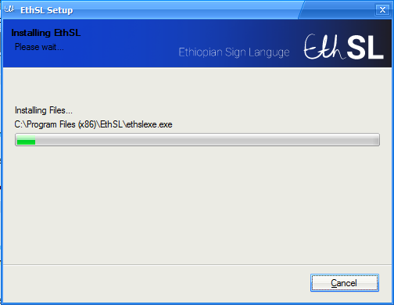

* + - 1. Finish Installation

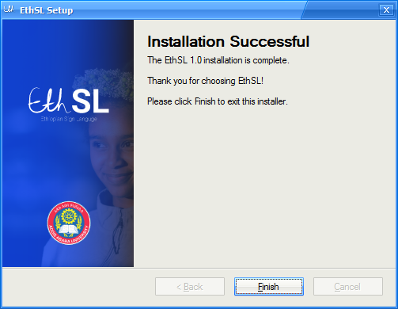

* + - 1. Shortcuts

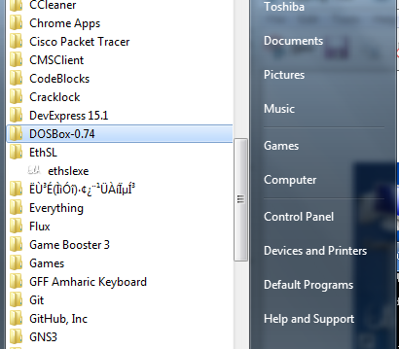

## 6.3 How to operate the system

A. How to start the system

Double Click on the desktop shortcut

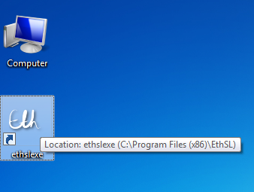

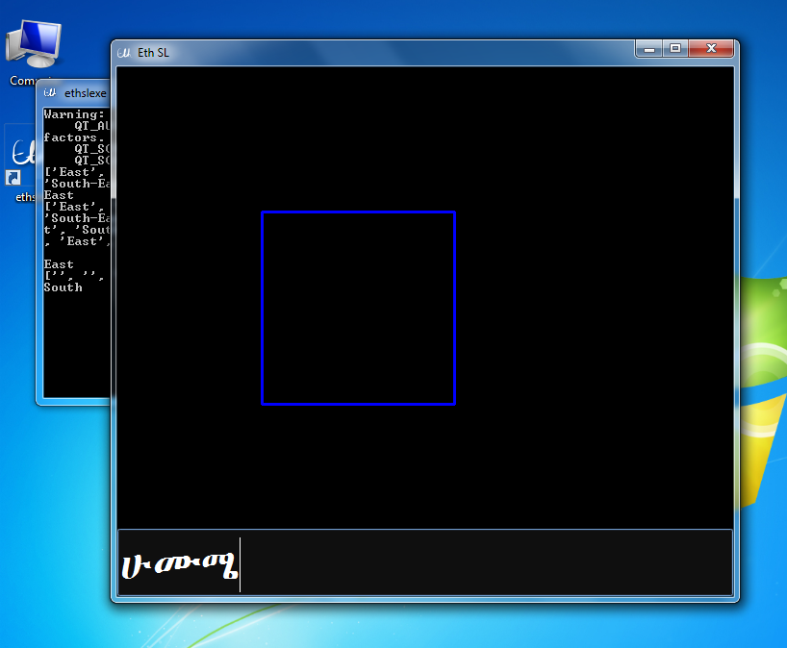

**B.** How to write consonants

1. Put your hand in the rectangle signing an Eth SL character

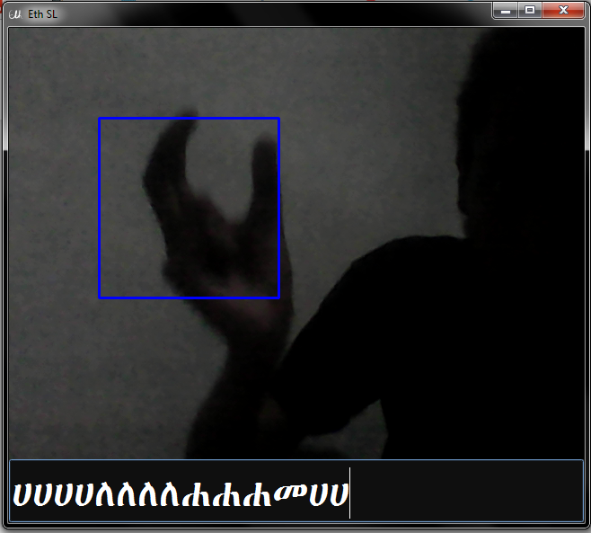

1. Then, keep hands still until letter appears in the text box



**C.** How to write vowels

1. Put your hand in the rectangle

v

2. Move hands according to the vowel

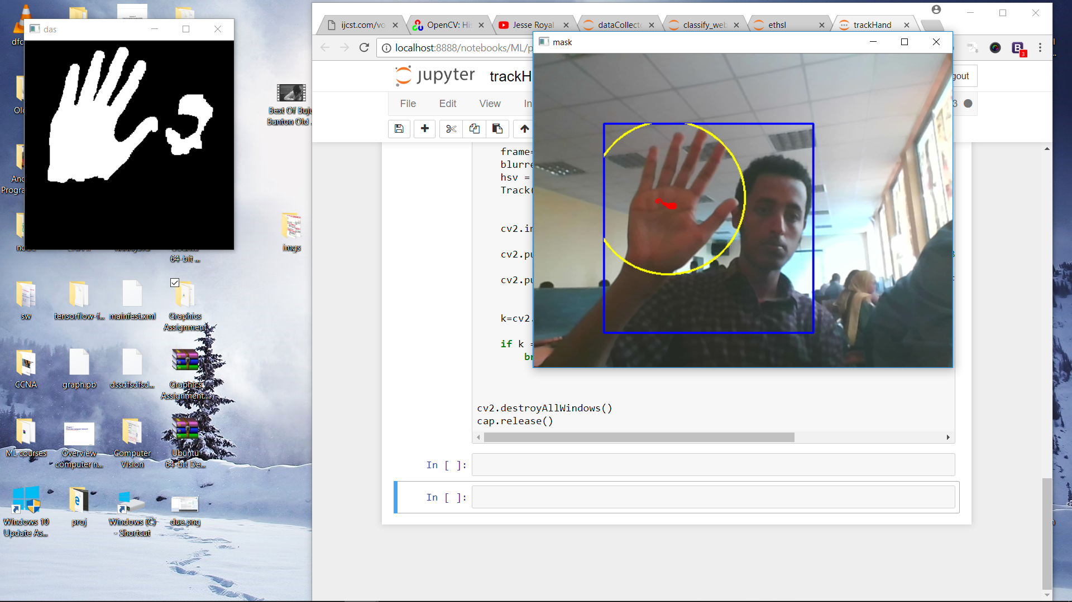

**Vowel Movements**

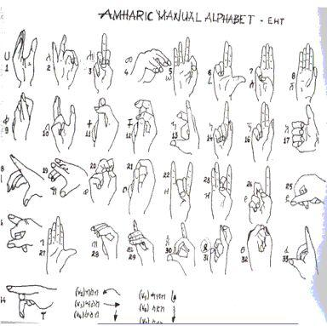

**Space and Delete**

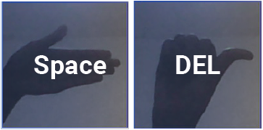

Use these custom signs to put a space in between characters and delete characters

# **Chapter 7: CONCLUSION AND RECOMMENDATION**

## **7.1 Conclusion**

This project provides a way to translate Ethiopian sign language finger spelling to text. In an everyday scenario this would have been done using a translator. This system allows the user to translate sign language from their laptop or desktop (which has a webcam). In the software we have implemented both the recognition of consonants and vowels. Due to the time constraints the amount to data gathered to train our system was limited.

We believe that this project paves a way in removing the barrier that language creates. Especially between the disabled, whose problems are mostly overlooked, and the community.

## **7.2 Recommendation**

To get the optimum performance from the software make sure to use it under good lighting conditions. The quality of the webcam also matters.

The code and dataset of this project will be publically available to the developers’ community in hopes of encouraging development on this project. This project can be further pushed to include words and phrases of the Ethiopian sign language.

# **BIBLIOGRAPHY**

1. "Deafness and Hearing Loss". *World Health Organization*. N.P., 2017. Web. 2 Nov. 2017.
2. "Census 2007". *Central Statistics Agency of Ethiopia*. N.P., 2017. Web. 2 Nov. 2017.
3. *Baseline Study On The Status Of Persons With Disabilities And The Influence Of The African Decade Pronouncement In Ethiopia*. 1st ed. FDRE Ministry of Labor and Social Affairs, 2010. Print.
4. "Sign Language". *En.wikipedia.org*. N.P., 201. Web. 2 Nov. 2017.
5. "Deaf Sign Language". *Ethnologue*. N.P., 2017. Web. 2 Nov. 2017.
6. "Ethiopian Sign Languages". *En.wikipedia.org*. N.P., 2017. Web. 2 Nov. 2017.
7. Masresha Tadesse, “Automatic translations of Amharic text to Ethiopian Sign Language”, *Unpublished Master’s Thesis,* Addis Ababa University, 2010.
8. Vista Wide, "World Language and Culture", Available at *http://www.vistawide.com*  */languages/top_30_languages.htm, Last accessed on 2 Nov. 2017.*
9. *Dagnachew Feleke, “Machine Translation System for Amharic Text to Ethiopian Sign Language”, Unpublished Master’s Thesis, Addis Ababa University, 2011.*
10. *Legesse Zerubabel, “Ethiopian Finger Spelling Classification”, Unpublished Master’s Thesis, Addis Ababa University, 2008.*
11. *Eyob Gebretinsae,”Vision Based Finger Selling Recognition for Ethiopian Sign Language”, Unpublished Master’s Thesis, Addis Ababa University, 2012.*
12. *Yonas Admasu and Raimond Kumudha, “Ethiopian Sign Language Recognition using Artificial Neural Network”, 10th International Conference on Digital Object Identifier, pp 995-1000, 2010.*
13. Mahendran, “Skin tone detection Mathlab code”*,* Availble at: *http://mahendranmathan.blogspot.com/2013/01/skin-tone-detection-matlab-code.html,Last* *accessed on January 12,2013.*
14. *Tefera Gimbi, ”* *Recognition of Isolated Signs in Ethiopian Sign Language”, Masters Thesis, Addis Ababa University, 2014.*
15. *Spiral Development Model Spiral development https://en.wikipedia.org/wiki/Spiral_model*

# **APPENDIX**

## A.1 Appendix 1

**Artificial neural networks** (**ANNs**): are computing systems inspired by the [biological neural networks](https://en.wikipedia.org/wiki/Biological_neural_network) that constitute animal brains. Such systems learn (progressively improve performance) to do tasks by considering examples, generally without task-specific programming. For example, in image recognition, they might learn to identify images that contain cats by analyzing example images that have been manually [labeled](https://en.wikipedia.org/wiki/Labeled_data) as "cat" or "no cat" and using the analytic results to identify cats in other images. They have found most use in applications difficult to express in a traditional computer algorithm using [rule-based programming](https://en.wikipedia.org/wiki/Rule-based_programming). [7]

## A.2 Appendix 2

|  |  |  |
| --- | --- | --- |
| **S – SRP** | The Single Responsibility Principle | A class should have one, and only one, reason to change. |
| **O – OCP** | The Open Closed Principle | You should be able to extend a classes behavior, without modifying it. |
| **L – LSP** | The Liskov Substitution Principle | Derived classes must be substitutable for their base classes |
| **I – ISP** | The Interface Segregation Principle | Make fine grained interfaces that are client specific. |
| **D – DIP** | The Dependency Inversion Principle | Depend on abstractions, not on concretions. |

**SOLID**: is an acronym for the first five object-oriented design principles by Robert C. Martin [4]. These principles, when combined together, make it easy for a programmer to develop software that are easy to maintain and extend. The five principles are summarized in the table below [8]:

**A.3 Appendix 3**

**GPLv3**: is an open-source license in which has permissions conditioned on making available complete source code of licensed works and modifications, which include larger works using a licensed work, under the same license. Copyright and license notices must be preserved. Contributors provide an express grant of patent rights [9].